Networking Task 02: Network Devices & IP Addressing

Objective
The purpose of this task is to understand common network devices, IP addressing concepts, and how
data travels within a network.

Part A: Network Devices Research
Research and explain the following network devices in your own words:
- Router
Purpose-Provide internet access to devices
How it works-forwards data packets between local network and internet using Ip address
Real World usage-laptop connect with wifi using home wifi routers

- Switch
Purpose- Connect multiple devices in same local network
How it works- Sends data only to specific device using mac address
Real World usage-Office computers connected together

- Hub
Purpose-Connects devices in a network
How it works- Broadcasts data to all connected devices
Real World usage- Small networks where simple device connection was needed

- Access Point
Purpose- Provides wireless network access to devices.
How it works- receives wired internet and converts it into Wi-Fi signals
Real World usage- Wi-Fi access points used in colleges

- Firewall
Purpose- Protects networks and devices from unauthorized access
How it works- MNonitors and filters incoming and outgoing network traffic based on security rules.
Real World usage- Windows defender firewall

- Modem
Purpose- Connects a home or office network to the ISP
How it works- Converts digital data from devices into signals that can travel through internet cables
Real World usage- Broadband modems

Part B: IP Address Classification
Identify whether the following IP addresses are Public or Private:
Explain why each IP belongs to its category

- 192.168.1.10
Private, Class C

- 10.0.0.5
Private, Class A

- 172.16.5.20
Private, Class B

- 8.8.8.8
Public Class A

- 1.1.1.1
Public, Class A

- 192.168.100.1
Public, Class C

Part C: Understanding Your Network
Find:
- IPv4 Address
- Default Gateway
- DNS Server
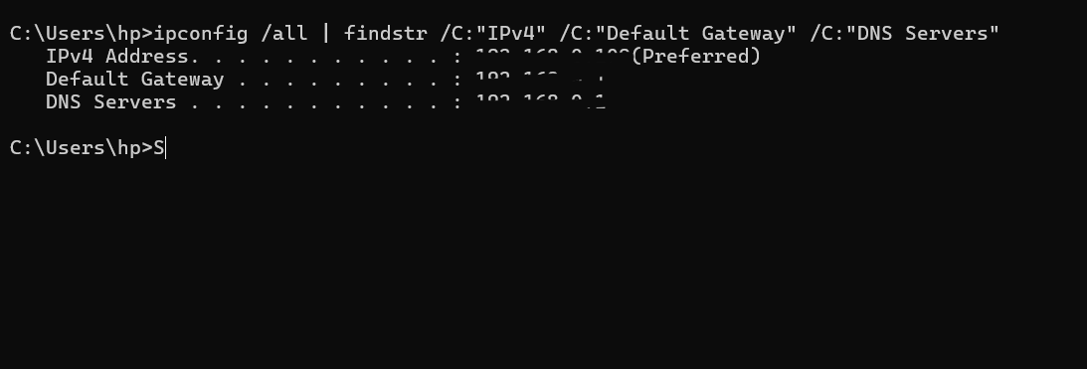
Answer:
- Which IP range does your device belong to?
Class C private IP range
- Is it Public or Private?
Its Private ip

- What role does your router play in your network?
It connects my device to the internet and transfers data

- What would happen if the DNS server stopped working?
Websites would not open using names like google.com because the system could not convert domain names into IP addresses.

- Part D: Network Communication Flow
Create a simple diagram showing what happens when you open:
www.google.com
Example:
Your Device ↓ Router ↓ DNS Server ↓ Google Server ↓ Response Back to Device
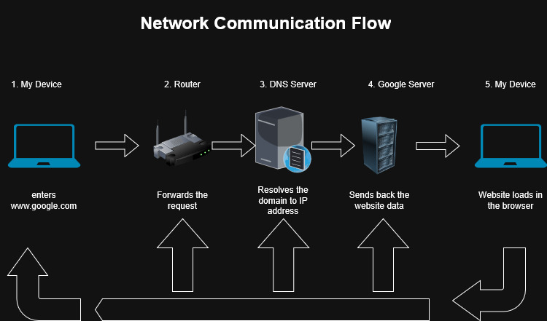
Explain each step in 2–3 lines
- My Device – The doman name www.google .com is entered in the browser
- Router- The router forwards the request to the DNS Server
- DNS Server - It resolves the domain www.google.com to IP address 142.250.72.206
- Google Server – IT sends back the website data
- My Device – Receives the data and the website loads on the browser

Part E: Practical Command Exercise
Run
- ipconfig /all

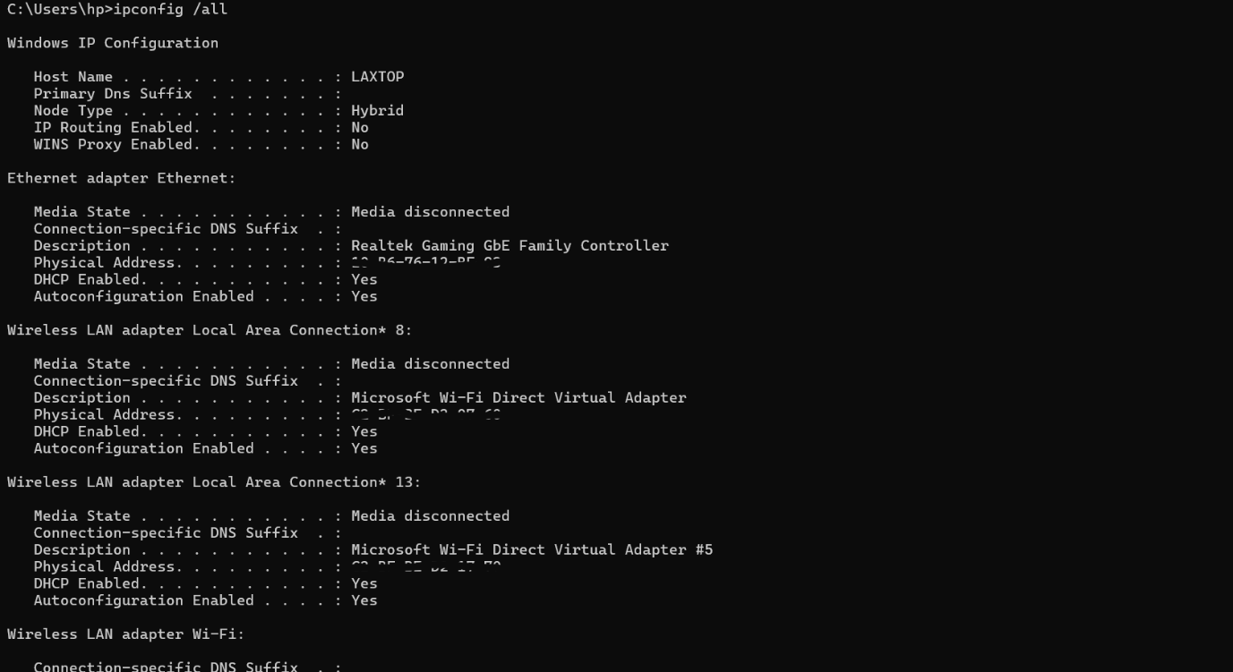
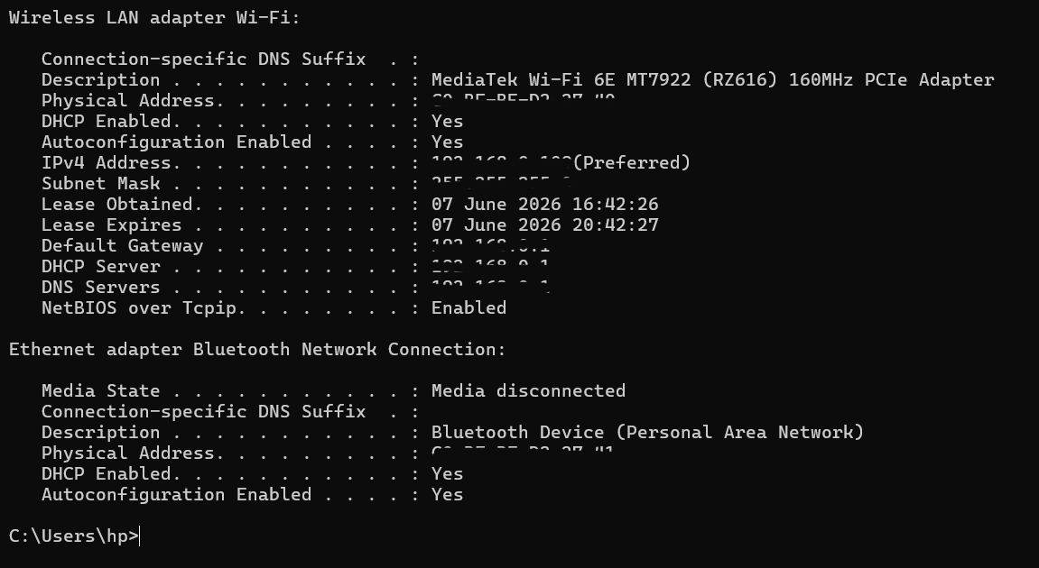

- nslookup google.com
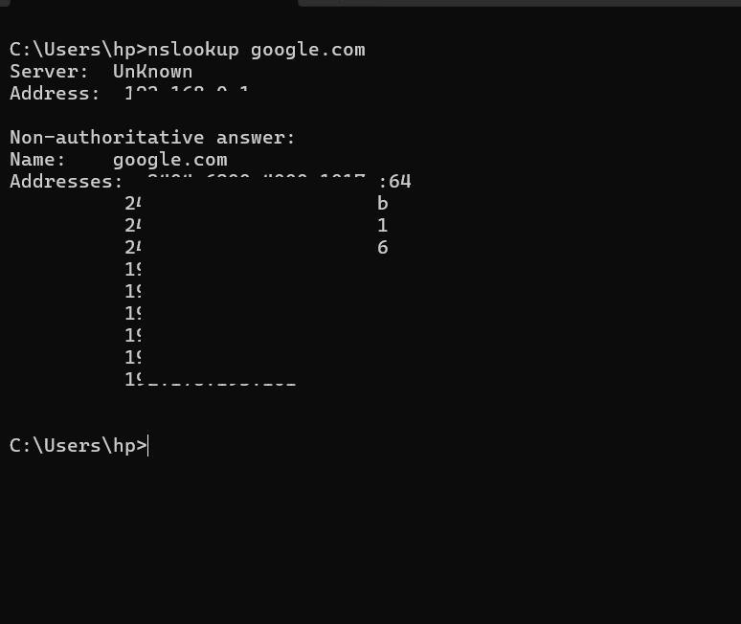

- ping google.com
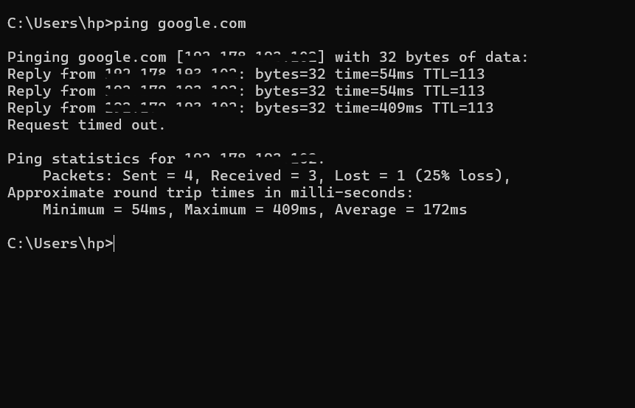
- What IP address did DNS return for Google?
192.XXX.XXX.XXX for google.com

- Was the ping successful?
YES

- Why is DNS important before communication begins?
DNS is important because it converts website names like google.com into IP addresses so the device can locate and communicate with the correct server.

